**Automatic Solar Tracking System**

**Presented by Group A**

**Technical Overview:**

The **Automatic Solar Tracking System** employs a combination of sensors, servos, and a microcontroller to achieve precise tracking of sunlight. By constantly monitoring light intensity from different directions, the system calculates the optimal orientation for the solar panel and adjusts its position accordingly.

**Features:**

• Tracks sunlight in two axes: horizontal and vertical.

• Uses photoresistors to detect light intensity from multiple directions.

• Automatically adjusts solar panel orientation for optimal energy absorption.

• Energy-efficient design with adjustable sensitivity and response speed.

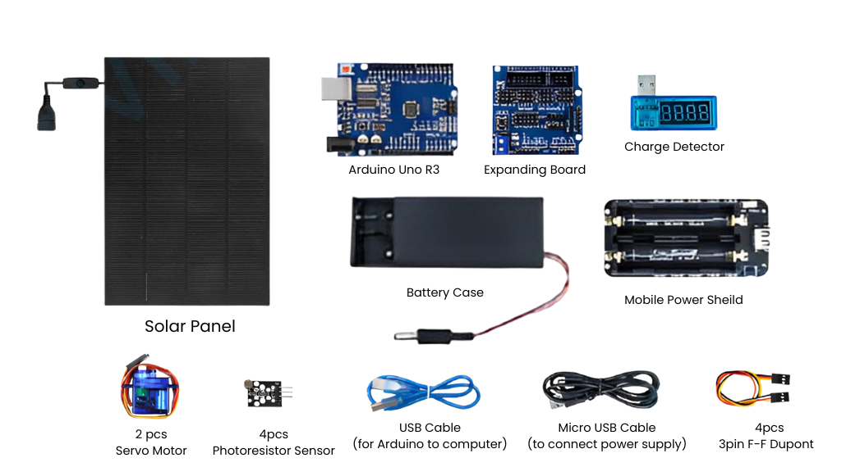**Main Components Overview:**

**System Architecture:**

1.) **Solar Panel**

The central component of the project. Converts sunlight into electrical energy, demonstrating the effectiveness of solar tracking in maximizing energy capture.

Key Features:

• Converts solar energy into electricity

• Provides a real-world application for renewable energy.

2.) **Arduino Uno**

Acts as the "brain" of the system. It processes data from the light sensors, computes the necessary adjustments for optimal solar tracking, and sends control signals to the servo motors.

Key Features:

• Compatible with numerous sensors and actuators

• Easy-to-use development environment (Arduino IDE)

3.) **Expanding Board**

Provides additional connection points and simplifies wiring for the Arduino. This ensures neat and organized connections, especially when working with multiple components.

Key Features:

• Reduces clutter in circuit design

• Ensures secure connections for stable operation

4.) **Photoresistive Sensors (LDRs)**

This sensor array measures the light intensity from four quadrants (top-left, to-right, bottom-left, bottom-right). It provides analog signals corresponding to the amount of light in each direction.

Key Features:

• Sensitive to light changes

• Cost-effective and easy to integrate into the circuit

5.) **Servo Motors**

Provide mechanical movement to adjust the solar panel's position. One servo controls horizontal rotation, while the other adjusts the vertical tilt.

Key Features:

• Precise angular movement

• Lightweight and energy efficient

6.) **Charge Detector**

Monitors the system's power levels, ensuring that the system remains functional by managing the charge from the solar panel or battery.

Key Features:

• Prevents overcharging or deep discharge of the battery

• Improves the lifespan and efficiency of the power supply

7.) **Mobile Power Shield**

Converts the power from the 18650 battery to a stable voltage suitable for powering the Arduino and other components.

Key Features:

• Protects the system from voltage fluctuations

• Ensures a steady power supply for uninterrupted operation

8.) **Battery Case**

Holds the 18650 lithium battery securely and provides easy connections to the power shield.

Key Features:

• Protects the battery from physical damage

• Simplifies integration of the battery into the system

9.) **3x3pin F-F Dupont Wires**

Used to make secure, flexible connections between components. These wires are essential for signal transmission and power supply.

Key Features:

• Easily detachable for testing and debugging

• Prevents loose connections, ensuring system reliability

10.) **USB Cable & Micro USB Cable**

Used to upload the code from the computer to the Arduino and provide power to the system during development or testing.

Key Features:

• Essential for programming the microcontroller

• Versatile for both data transfer and power supply

**Why Each Components Matters in System’s Functionality?**

1.) **Control & Computation (Arduino):**  
Without the Arduino, the system lacks the ability to process sensor data and control servo motors effectively.

2.) **Sensing (LDRs):**  
The sensors are the eyes of the system. Accurate light detection is critical for the system's efficiency.

3.) **Actuation (Servos):**  
Servo motors execute the instructions from the Arduino to physically adjust the solar panel, making tracking possible.

4.) **Power Management (Battery, Power Shield, Charge Detector):**  
Stable and reliable power is essential for continuous operation, especially in remote or outdoor setups.

5.) **Energy Harvesting (Solar Panel):**  
The solar panel is the purpose of the project. Its effectiveness is directly influenced by the precision of the tracking system.

Note:

Our solar panel have high requirement of light intensity. The maximum power is the peak value under direct sunlight at noon. The sunlight in the morning and the evening is not that strong to reach the maximum power of solar. So, taking the advantage of getting highest intensity sunlight at noon make storing electricity faster.

6.) **Connectivity (Dupont Wires, Expanding Board):**  
Proper wiring ensures seamless communication between components, making the system stable and easy to maintain.

**Code Overview:**

1.) **Including Libraries**



Imports the Servo library, which provides functions to control servo motors easily. It enables commands like attach() and write() to control servo positions.

2.) **Defining Pins**



Assigns specific digital pins to the horizontal and vertical servo motors for connection and control.



**tol:** Determines the sensitivity of the system to light intensity differences. Lower values make the system more responsive but risk over-adjustments.

**dtime:** Controls the delay between adjustments. Lower values make the system faster but can increase power consumption.

3.) **Servo Settings**

Initialization of servo objects for controlling the motors. It sets the starting angles and rotation limits to avoid over-rotation and prevent mechanical damage.

4.) **Sensor Definitions**

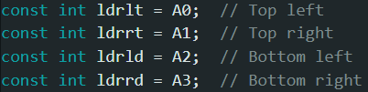

Assigns analog pins to the four photoresistors for detecting light intensity in different directions.

5.) **Setup Function**

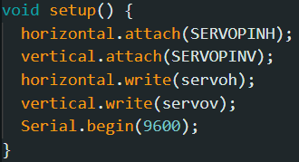

By creating this function, it attaches the servos to their respective pins and sets their initial angles to ensure the solar panel starts in a neutral position. It also initializes serial communication for debugging and monitoring sensor values.

**====MAIN FUNCTION===**

6a.) **Read Sensor Values**

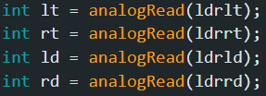

The purpose is to read the light intensity from all four photoresistors. The output must be higher values indicate greater light intensity.

6b.) **Calculate Averages**

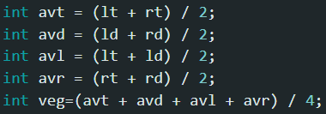

This initialized the calculation of the average light intensity for top-bottom and left-right directions. It makes easier for the system to identify the direction with the lightest.

6c.) **Adjust Sensitivity and Delay**

**veg**: Average light intensity across all sensors.

Dynamically adjusts the system's sensitivity and response time based on ambient light.

• Lower light = higher sensitivity and slower response.

• Higher light = reduced sensitivity and faster response.

6d.) **Adjust Vertical Angle**

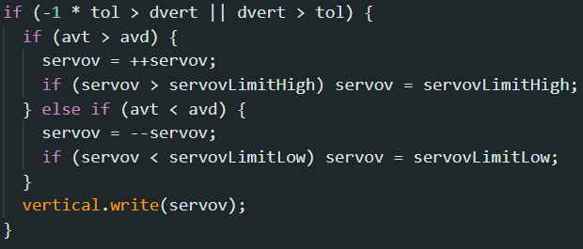

**dvert:** Difference between top and bottom average light intensities.

Moves the panel vertically if the light difference exceeds the sensitivity threshold (tol). If the top sensors detect more light, the panel tilts upward. While, if the bottom sensors detect more light, the panel tilts downward.

6e.) **Adjust Horizontal Angle**

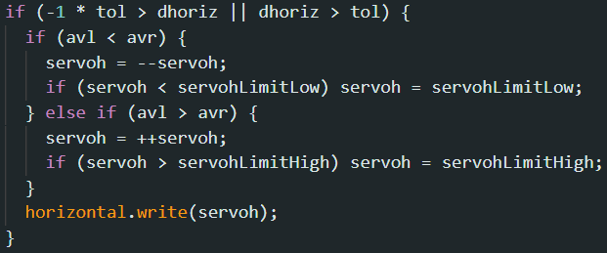

**dhoriz**: Difference between left and right average light intensities**.**

Moves the panel horizontally based on the light intensity difference. If the right sensors detect more light, the panel rotates right. While, if the left sensors detect more light, the panel rotates left.

6f.) **Delay for Stability**



Introduces a delay to avoid excessive movement and allow the system to stabilize before the next adjustment.

**Servo Angle**

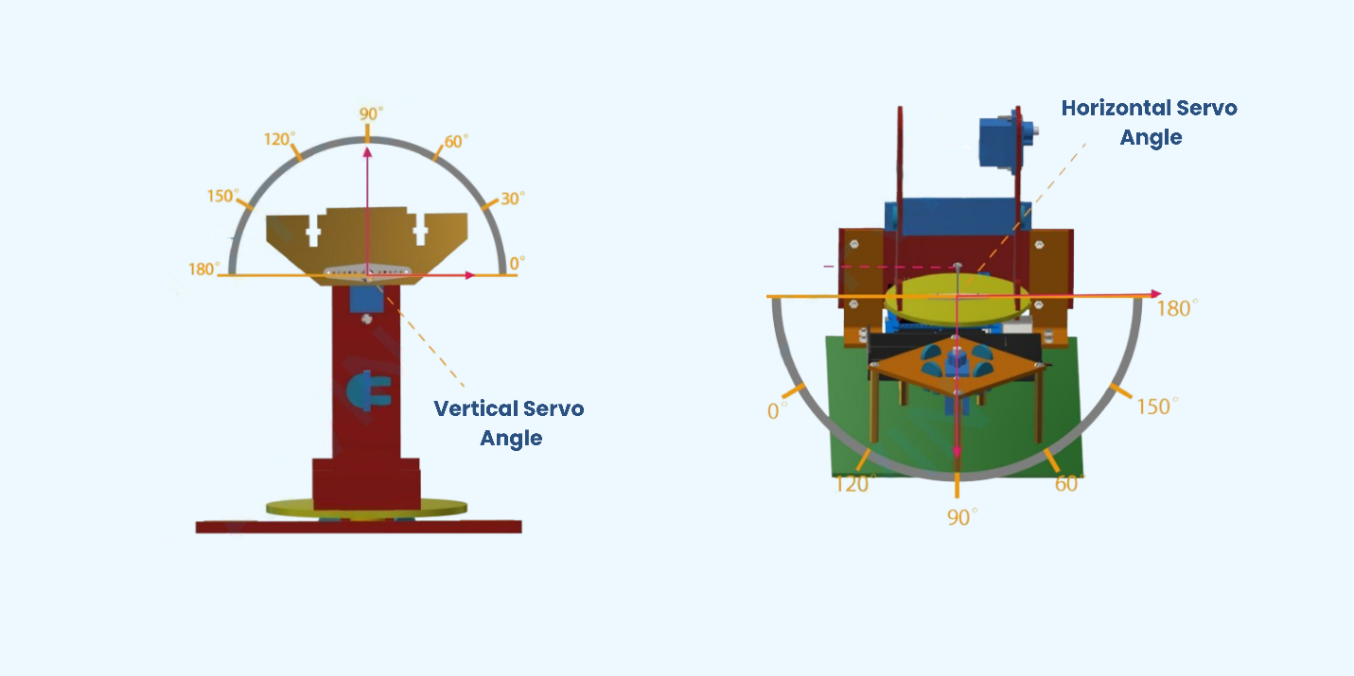

**Wirings and Indications**

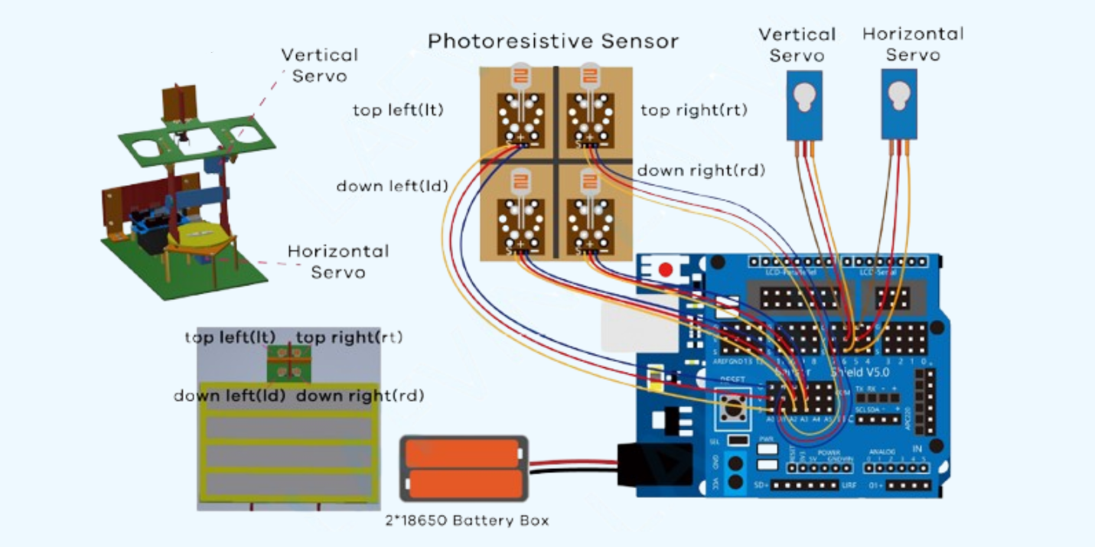

**Power Shield**

**Solar Charging**

**Battery Charging**

**Device Charging**

